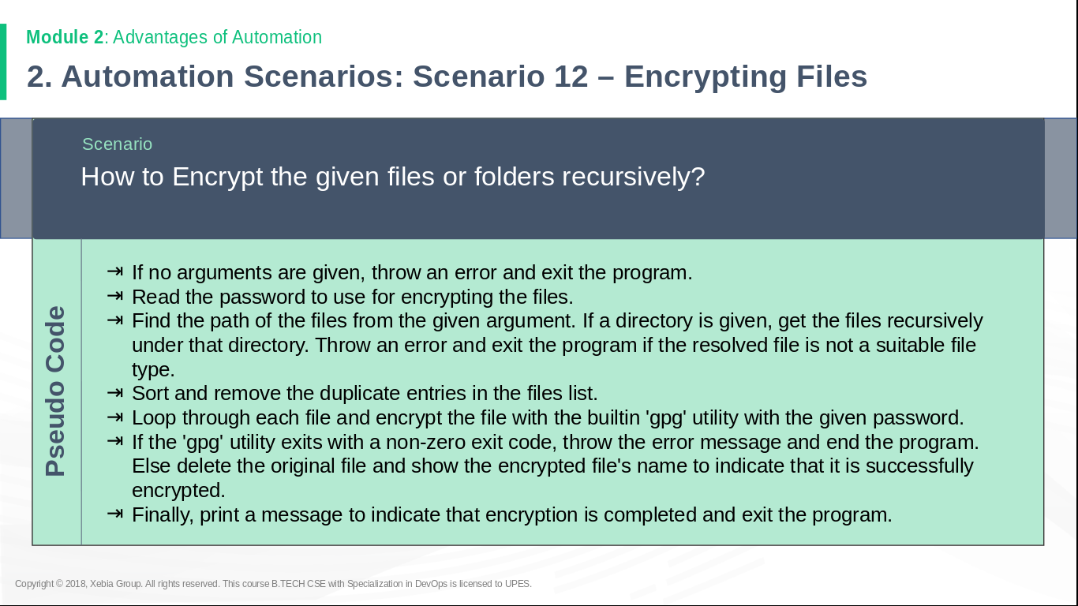

Algorithm:

- If no arguments are given, throw an error and exit the program.

- Read the password to use for encrypting the files in a variable.

- Find the path of the given argument by realpath.

- Create a function in which check the provided agrument is a directory or a file.

- If a directory is given, get the files recursively under that directory and sort and remove the duplicate entries in the files list by ls | uniq and store it in an array.

- Pass the output of ls | uniq to the function one by one by indices of the created array in a loop i.e calling the same function recursively.

- If a file a is given, do step 8

- Loop through each file and encrypt the file with the builtin 'gpg' utility with the given password.

- If the 'gpg' utility exits with a non-zero exit code, throw the error message and end the program.
Else delete the original file and show the encrypted file's name to indicate that it is successfully encrypted.
#!/bin/bash

if [ -z "$1" ]; then #In this line we check that an argument is provided or not
echo "No file provided" >&2
exit 1
fi

read -p "Enter the password" pass #reading the password which would be used for encrypton

function func()
{
file_name=$1
if [ -d `realpath $file_name` ]; then #checking if the provided argument is a directory

cd `realpath $file_name` #going to the location of the directory

array=(`ls | uniq `) #saving the output of the “ls | uniq” in a an array

len=${#array[*]} #storing the length of the array in a variable
i=0
while [ $i -lt $len ]; do #looping through all the indices of the array

echo "${array[$i]}" #displaying the file in the index right now
func ${array[$i]} #recursively calling the function
let i++ #increasing the counter

done
fi

if [ -f `realpath $file_name` ]; then #checking if the argument is a file

test= echo $pass | gpg -c --batch --yes --passphrase-fd 0 $file_name #encrypting the file with the given password and storing the return value of the gpg in a variable

if [ "$test" == "1" ]; then #checking if the gpg executed properly or not
echo "Bad signature: gpg not executed properly" >&2 #writing to the standard error
exit 1

elif [ "$test" == "2" ]; then #checking if the gpg executed properly or not
echo "unexpected error: gpg not executed properly" >&2 #writing to the standard error
exit 1

else
rm $file_name #deleting the original file
echo " $file_name.gpg " #displaying the gpg created
fi
fi
}
func $1
ls list directory contents

SYNOPSIS
ls [OPTION]... [FILE]...

DESCRIPTION
List information about the FILEs (the current directory by default).
Sort entries alphabetically if none of -cftuvSUX nor --sort is speci‐
fied.

uniq report or omit repeated lines

SYNOPSIS
uniq [OPTION]... [INPUT [OUTPUT]]

DESCRIPTION
Filter adjacent matching lines from INPUT (or standard input), writing
to OUTPUT (or standard output).
With no options, matching lines are merged to the first occurrence.

realpath print the resolved path

SYNOPSIS
realpath [OPTION]... FILE...

DESCRIPTION
Print the resolved absolute file name; all but the last component must
exist
rm remove files or directories

SYNOPSIS
rm [OPTION]... [FILE]...

DESCRIPTION
This manual page documents the GNU version of rm. rm removes each
specified file. By default, it does not remove directories.

If the -I or --interactive=once option is given, and there are more
than three files or the -r, -R, or --recursive are given, then rm
prompts the user for whether to proceed with the entire operation. If
the response is not affirmative, the entire command is aborted.

Otherwise, if a file is unwritable, standard input is a terminal, and
the -f or --force option is not given, or the -i or --interactive=al‐
ways option is given, rm prompts the user for whether to remove the
file. If the response is not affirmative, the file is skipped.

gpg OpenPGP encryption and signing tool

SYNOPSIS
gpg [--homedir dir] [--options file] [options] command [args]

DESCRIPTION
gpg is the OpenPGP part of the GNU Privacy Guard (GnuPG). It is a tool
to provide digital encryption and signing services using the OpenPGP
standard. gpg features complete key management and all the bells and
whistles you would expect from a full OpenPGP implementation.

There are two main versions of GnuPG: GnuPG 1.x and GnuPG 2.x. GnuPG
2.x supports modern encryption algorithms and thus should be preferred
over GnuPG 1.x. You only need to use GnuPG 1.x if your platform
doesn't support GnuPG 2.x, or you need support for some features that
GnuPG 2.x has deprecated, e.g., decrypting data created with PGP-2
keys.

If you are looking for version 1 of GnuPG, you may find that version
installed under the name gpg1.

Commands and options we have used:

--symmetric
-c Encrypt with a symmetric cipher using a passphrase. The default
symmetric cipher used is AES-128, but may be chosen with the
--cipher-algo option. This command may be combined with --sign
(for a signed and symmetrically encrypted message), --encrypt
(for a message that may be decrypted via a secret key or a
passphrase), or --sign and --encrypt together (for a signed mes‐
sage that may be decrypted via a secret key or a passphrase).
gpg caches the passphrase used for symmetric encryption so that
a decrypt operation may not require that the user needs to enter
the passphrase. The option --no-symkey-cache can be used to
disable this feature.

--batch
--no-batch
Use batch mode. Never ask, do not allow interactive commands.
--no-batch disables this option. Note that even with a filename
given on the command line, gpg might still need to read from
STDIN (in particular if gpg figures that the input is a detached
signature and no data file has been specified). Thus if you do
not want to feed data via STDIN, you should connect STDIN to
g‘/dev/null’.

It is highly recommended to use this option along with the op‐
tions --status-fd and --with-colons for any unattended use of
gpg.

--yes Assume "yes" on most questions.

--passphrase-fd n
Read the passphrase from file descriptor n. Only the first line
will be read from file descriptor n. If you use 0 for n, the
passphrase will be read from STDIN. This can only be used if
only one passphrase is supplied.

Note that since Version 2.0 this passphrase is only used if the
option --batch has also been given. Since Version 2.1 the
--pinentry-mode also needs to be set to loopback.

--passphrase-file file
Read the passphrase from file file. Only the first line will be
read from file file. This can only be used if only one
passphrase is supplied. Obviously, a passphrase stored in a file
is of questionable security if other users can read this file.
Don't use this option if you can avoid it.

Note that since Version 2.0 this passphrase is only used if the
option --batch has also been given. Since Version 2.1 the
--pinentry-mode also needs to be set to loopback.

